**HW4 Report**

Ziyang Lin zlin32@jhu.edu

**Dataset**

The data is cifar-100 image dataset. The input of my neural network is a fixed-sized 28 × 28 RGB image. The training data has 45000 image and the evaluation data has 5000 images.

**Model Architecture**

I used three different CNN models for classifying the data. The first one is the simple convolutional network model.

|  |  |  |
| --- | --- | --- |
| Model Configuration | | |
| Simple CNN | Resnet 34 | VGG 19 |
| Input (28 × 28 RGB image) | | |
| Conv3-32 | $\left(\begin{matrix}3×3 & 64 \\ 3×3 & 64\end{matrix}\right) ×3$ (stride 1) | Conv3-64 |
| Maxpool | Conv3-64 |
| Conv3-64 | $\left(\begin{matrix}3×3 & 128 \\ 3×3 & 128\end{matrix}\right) ×4$ (stride 2) | Maxpool |
| Maxpool | Conv3-128 |
| Conv3-256 | $\left(\begin{matrix}3×3 & 256 \\ 3×3 & 256\end{matrix}\right) ×6$ (stride 2) | Conv3-128 |
| Maxpool | Maxpool |
| FC-1024 | $\left(\begin{matrix}3×3 & 512 \\ 3×3 & 512\end{matrix}\right) ×3$ (stride 2) | Conv3-256 |
| FC-512 | Conv3-256 |
| FC-256 | Average Pool | Conv3-256 |
|  | FC-512 | Conv3-256 |
|  |  | Maxpool |
|  |  | Conv3-512 |
|  |  | Conv3-512 |
|  |  | Conv3-512 |
|  |  | Conv3-512 |
|  |  | Maxpool |
|  |  | FC-512 |
| Output (100 classes) | | |

**Model Improvement**

All models are initialized with the batch size 128, learning rate 0.001 and Adam optim. For simple CNN model, I have used dropout and data augmentation to improve the performance of the model. For Resnet model, I used batchnorm, data connection and regularization. And Resnet itself has skip connection, so I want to use Resnet to check out whether skip connection will improve the image recognition greatly in this problem. Finally, I used dropout, batchnorm, data augmentation and regularization in VGG model.

I set the momentum to 0.9 and set the parameter of L2 regularization to 0.0005. For data augmentation, I make the training data flip up to down and flip left to right in 0.5 probability, trying to make my model more robust and perform well in prediction.

**Model result**

The experiment result shows in below table. I found using different optimizer has no influence in the result of the model. As I add momentum, the model the converge faster and perform better. And I found that the data augmentation I realized make the model has worse prediction, maybe the reason is that I just rotated the images but didn’t extend the dataset using the data I process, which make my model miss some features in training. In the VGG model, the batchnorm can help model performance increase rapidly.

|  |  |  |
| --- | --- | --- |
| **Model** | **Improvement** | **Loss** |
| CNN | **-** Batch size  **-** Batch size + Dropout  **-** Batchsize+ Dropout +Data Augmentation | 0.600  0.490  0.550 |
| **Best:** Batch size + Dropout | 0.490 |
| Resnet | **-** Batch size  **-** Batch size (SGD)  **-** Batch size (SGD) + Batchnorm  **-** Batch size (SGD) + Batchnorm + Momentum  **-** Batch size (SGD) + Batchnorm + Momentum + Regularization  **-** Batch size (SGD) + Batchnorm + Momentum + Regularization  + Data Augmentation | 0.520  0.550  0.610  0.500  0.480  0.550 |
| **Best:** Batch size (SGD) + Batchnorm + Momentum + Dropout  +Regularization | 0.480 |
| VGG | **-** Batch size (Adam)  **-** Batch size (SGD)  **-** Batch size (SGD) + Batchnorm  **-** Batch size (SGD) + Batchnorm+ Momentum  **-** Batch size (SGD) + Batchnorm + Momentum + Data Augmentation  **-** Batch size (SGD) + Batchnorm + Momentum + Dropout  + Data Augmentation  **-** Batch size (SGD) + Batchnorm + Momentum + Dropout  +Regularization +Data Augmentation | 0.970  0.970  0.490  0.460  0.500  0.460  0.450 |
| **Best:** Batch size (SGD) + Batchnorm + Momentum + Dropout  +Regularization | 0.370 |

The best model is VGG model that use batchnrom, momentum, dropout and regularization, the loss is 0.370 and the score in testing dataset is 0.524.

The following figure shows the improvement in the model training process.

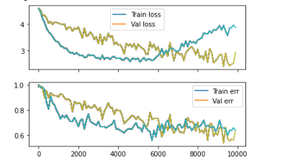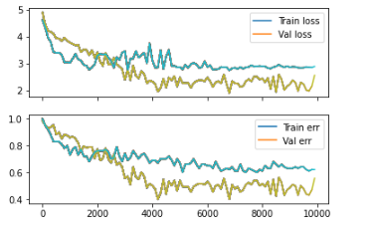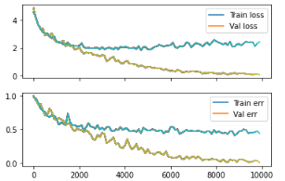

Figure 1a. CNN Figure 1b. Resnet Figure 1c. VGG